



**08_Game Play Analysis I**

Write a solution to find the first login date for each player.

Return the result table in any order.

**Difficult Level :** EASY

**DataFrame:**

**# Define the schema for the "Activity"**

**activity_schema = StructType([**

**StructField("player_id", IntegerType(), True),**

**StructField("device_id", IntegerType(), True),**

**StructField("event_date", StringType(), True),**

**StructField("games_played", IntegerType(), True)**

**])**

**# Define data for the "Activity"**

**activity_data = [**

**(1, 2, '2016-03-01', 5),**

**(1, 2, '2016-05-02', 6),**

**(2, 3, '2017-06-25', 1),**

**(3, 1, '2016-03-02', 0),**

**(3, 4, '2018-07-03', 5)**

**]**



**INPUT**

|  |  |  |  |
| --- | --- | --- | --- |
| **INPUT** | | | |
| **PLAYER_ID** | **DEVICE_ID** | **EVENT_DATE** | **GAMES_PLAYED** |
| **1** | **2** | **2016-03-01** | **5** |
| **1** | **2** | **2016-05-02** | **6** |
| **2** | **3** | **2017-06-25** | **1** |
| **3** | **1** | **2016-03-02** | **0** |
| **3** | **4** | **2018-07-03** | **5** |

**OUTPUT**

|  |  |
| --- | --- |
| **OUTPUT** | |
| **PLAYER_ID** | **FISRT_LOGIN** |
| **1** | **2016-03-01** |
| **2** | **2017-06-25** |
| **3** | **2016-03-02** |



**# Creating Spark Session**

**from pyspark.sql import SparkSession**

**from pyspark.sql.types import StructType,StructField,IntegerType,StringType**

**#creating spark session**

**spark = SparkSession. \**

**builder. \**

**config('spark.shuffle.useOldFetchProtocol', 'true'). \**

**config('spark.ui.port','0'). \**

**config("spark.sql.warehouse.dir", "/user/itv008042/warehouse"). \**

**enableHiveSupport(). \**

**master('yarn'). \**

**getOrCreate()**

**# Define the schema for the "Activity"**

**activity_schema = StructType([**

**StructField("player_id", IntegerType(), True),**

**StructField("device_id", IntegerType(), True),**

**StructField("event_date", StringType(), True),**

**StructField("games_played", IntegerType(), True)**

**])**

**# Define data for the "Activity"**

**activity_data = [**

**(1, 2, '2016-03-01', 5),**

**(1, 2, '2016-05-02', 6),**

**(2, 3, '2017-06-25', 1),**

**(3, 1, '2016-03-02', 0),**

**(3, 4, '2018-07-03', 5)**

**]**

**# Create a PySpark DataFrame**

**activity_df=spark.createDataFrame(activity_data,activity_schema)**

**activity_df.show()**

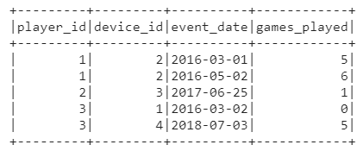

**rank_df=activity_df.withColumn("RK",rank().over(Window.partitionBy(activity_df['player_id']).orderBy(activity_df['event_date'])))**

**rank_df.show()**

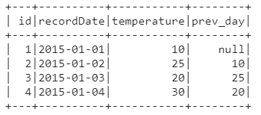

**rank_df.filter(rank_df["RK"] == 1).select("player_id",rank_df["event_date"].alias("First_Login")).show()**



